CHINMAYA INTERNATIONAL RESIDENTIAL SCHOOL
COIMBATORE

SAMPLE PAPER – 2010
CLASS : 07 SUBJECT: SCIENCE

- Dietary fibres are also known as:
A. Vitamins B. Minerals
ANSWER
C. Roughage D. Fats

- Identify the type of motion that is associated with the picture given below:
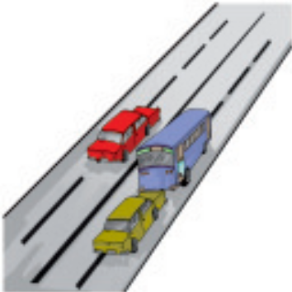
A. Linear motion B. Circular motion
ANSWER
C. Periodic motion D. Non periodic motion
- Identify the instrument used in the picture.
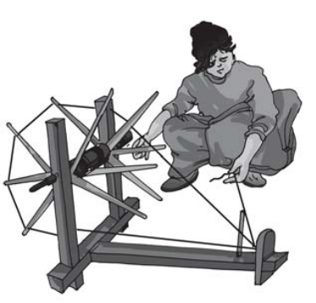
A. Hand pump B. Hand spinning wheel
ANSWER
C. Sewing machine D. Sieving machine

- Butter paper, Greased paper and oiled paper are examples of ---- substances:
A. Transparent B. Conductors
ANSWER
C. Translucent D. Opaque.

- Identify the picture:
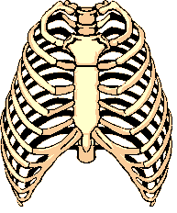
A. Human Skeleton B. Rib cage
ANSWER
C. Skull D. Hip joint.
- Gun power is a mixture containing

- Charcoal
- Sulphur, Potassium nitrate
- Charcoal, Potassium nitrate, Sulphur
- None.

